PRAKTIKUM BASIS DATA

MODUL 4
Scripting_SQL_Pemrosesan



Oleh:

(Cikal Chrestella Cora) (103122400051)

PROGRAM STUDI S1 REKAYASA PERANGKAT LUNAK DIREKTORAT KAMPUS PURWOKERTO UNIVERSITAS TELKOM
2026
JURNAL

- Soal 1
Jawaban:
SELECT "ID_THEATER", "PERIODE_START",
EXTRACT(DAY FROM NUMTODSINTERVAL("PERIODE_END" - "PERIODE_START", 'DAY')) AS LAMA_TAYANG_HARI
FROM "JADWAL"
WHERE "ID_FILM" = (SELECT "ID_FILM" FROM "FILM" WHERE
"JUDUL" = 'Habibie Ainun 3');
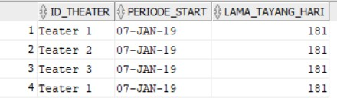

- Soal 2
Jawaban:
SELECT J."ID_THEATER", F."JUDUL",
T."KELAS",
T."HARGA", CASE
WHEN T."HARGA" < 50000 THEN 'Murah' WHEN T."HARGA" > 75000 THEN 'Mahal'
ELSE 'Normal'
END AS KATEGORI_HARGA FROM "JADWAL" J
JOIN "FILM" F ON J."ID_FILM" = F."ID_FILM"
JOIN "THEATER" T ON J."ID_THEATER" = T."ID_THEATER";

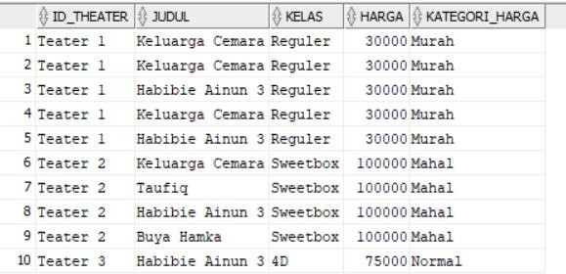

- Soal 3
Jawaban :
SELECT M."ID_MEMBER",
T."HARGA" AS HARGA_AWAL,
EXTRACT(YEAR FROM SYSDATE) - EXTRACT(YEAR FROM M."TGL_LAHIR") AS UMUR,
CASE
WHEN (EXTRACT(YEAR FROM SYSDATE) - EXTRACT(YEAR FROM M."TGL_LAHIR")) <= 32
THEN T."HARGA" * 0.9 ELSE T."HARGA"
END AS HARGA_SETELAH_DISKON FROM "TRANSAKSI" TR
JOIN "MEMBER" M ON TR."ID_MEMBER" = M."ID_MEMBER" JOIN "JADWAL" J ON TR."ID_JADWAL" = J."ID_JADWAL" JOIN "THEATER" T ON J."ID_THEATER" = T."ID_THEATER" ORDER BY UMUR ASC;

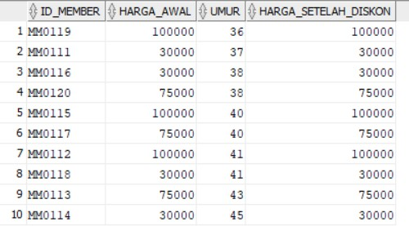

- Soal 4
Jawaban :
SELECT M."ID_MEMBER", M."NAMA",
F."JUDUL"
FROM "TRANSAKSI" T
JOIN "MEMBER" M ON T."ID_MEMBER" = M."ID_MEMBER" JOIN "JADWAL" J ON T."ID_JADWAL" = J."ID_JADWAL" JOIN "FILM" F ON J."ID_FILM" = F."ID_FILM"
WHERE F."DURASI" >= 100
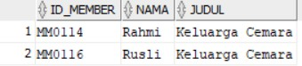
AND TO_NUMBER(SUBSTR(M."NO_HP", -1)) = 8;

- Soal 5
Jawaban :
SELECT TR."ID_MEMBER", J."ID_FILM", J."ID_THEATER",
TH."HARGA" AS HARGA_ASLI,

(TH."HARGA" * 0.3) AS HARGA_SETELAH_DISKON FROM "TRANSAKSI" TR
JOIN "JADWAL" J ON TR."ID_JADWAL" = J."ID_JADWAL" JOIN "FILM" F ON J."ID_FILM" = F."ID_FILM"
JOIN "THEATER" TH ON J."ID_THEATER" = TH."ID_THEATER"
WHERE F."JUDUL" = 'Keluarga Cemara'
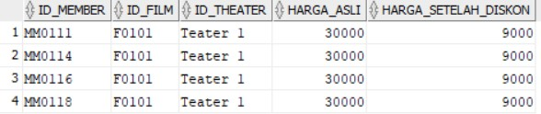
AND TR."TANGGAL" >= TO_DATE('2019-12-19', 'YYYY-MM-DD');

